
Royd Nursery Infant School
Carr Road, Deepcar
Sheffield, S36 2PR
Tel 0114 288 2594
Email royd.enquiries@deepcarprimarypartnership.co.uk
www.roydnurseryinfants.co.uk
Executive Headteacher: Louise Jones

8 January 2026

Dear Parents / Carers

We would like to invite you in to School for a Stay and Play session with your child on
- Tuesday 10th February 2026 @ 2:15-3:00 PM OR
- Thursday 12th February 2026 @ 2:15-3:00 PM

There will be a carousel of activities where children will be able to explore and investigate enhanced provision activities, based around their current topic ‘Where does the Snow go’? The sessions will both be from 2.15pm – 3:00pm.

Should your child not attend provision on a Tuesday or Thursday, parents/carers are welcome to join either session and school must be notified of the date you wish to attend. Your child must be accompanied by an adult due to ratio’s.

The stay and play session is a chance for parent/carers to be involved with their child during school time and therefore, siblings are not allowed at this activity. Please respect this request – thank you

Please complete and return the slip below if you would like to join us. It would be lovely to see you all.

Yours sincerely,
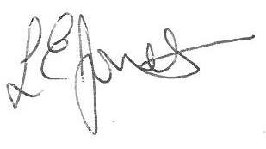

Louise Jones Sean Sly
Executive Head Acting Deputy Head

2 Year Provision Stay and Play February 2026

Name of child :

Yes I / We would like to join you for the Stay and Play

Please select either 10th February OR 12th February

No I / We are unable to attend.

Signed ____________________________________________________ Parent/carer









