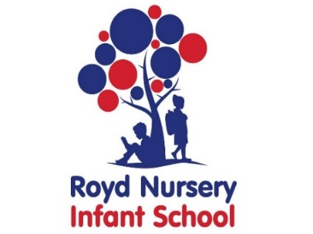
Royd Nursery Infant School
Carr Road, Deepcar
Sheffield, S36 2PR
Tel 0114 288 2594
Email royd.enquiries@deepcarprimarypartnership.co.uk
www.roydnurseryinfants.co.uk
Executive Headteacher: Louise Jones

9 February 2026

Dear Parent/Carers,

Parents Evening for 2 Year Old provision, will take place on the following dates:

- Wednesday 18 March 2026 3.30 pm to 5.50 pm

- Monday 23 March 2026 3.30 pm to 5.50 pm

Parent/carers will be able to come in to the classroom for their appointment. The procedure will be for parent/carers to arrive outside your child’s classroom door, via the main school gate two minutes before the appointment time. The teacher will then come out to collect you.

To ensure that everybody has a fair chance of booking an appointment, please complete the form overleaf indicating your preference and return the form by Thursday 26 February 2026 at the latest and School will endeavour to meet your request. Please note, due to the volume of replies email requests will not be accepted.

Confirmation of appointment times will be sent by letter the afternoon of Monday 2 March 2026. Thank you

Yours sincerely,
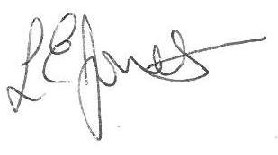

Louise Jones Sean Sly
Executive Head Acting Deputy Head











-----------------------------------------------------------------------------------------------------------------------------------------------
2 Yr Provision Parents Evening March 2026

Name of Child : Class : E2

Wednesday 18 March between 3.30 pm and 4.50 pm

Wednesday 18 March between 5.00 pm and 5.50 pm

Monday 23 March between 3.30 pm and 4.50 pm

Monday 23 March between 5.00 pm and 5.50 pm

