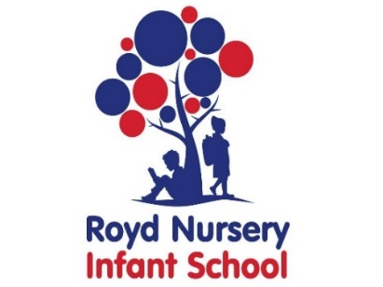
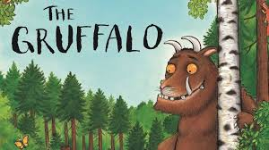
Royd Nursery Infant School
Carr Road, Deepcar
Sheffield, S36 2PR
Tel 0114 288 2594
Email enquiries@royd.sheffield.sch.uk
www.roydnurseryinfants.co.uk
Headteacher: Louise Jones

10th February 2026

WORLD BOOK DAY 2026 Monday 2nd March – Friday 6th March

Dear Parents/Carers,

On Thursday 5th March it is World Book Day 2026. Nursery pupils will be taking part in World Book Weeks starting Monday 23rd February and ending Friday 6th March.

This is a worldwide celebration of reading, books, authors and illustrators. A key aim of World Book Day is to give every child in the UK and Ireland a book of their own to keep, by distributing World Book Day Tokens to children. Children can exchange this token for one of eight exclusive World Book Day Books at participating booksellers.

Reading is the biggest indicator to a child succeeding in the future.

‘Reading for pleasure is the single biggest indicator of a child's future success, more than family circumstances, parents’ educational backgrounds or income.’ – Organisation for Economic Co-Operation & Development.

The children in Nursery will be reading the story “The Gruffalo”. Throughout the week children will be completing activities around this story. We are asking that they either dress up as a book character or wear some comfy pajamas throughout the week Monday 2nd March to Friday 6th March. (If this is not manageable, please wear school uniform).

As part of our celebration of reading, we would also like to invite your child to take part in a whole school homework competition. Their task is to make something linked to their focus book “The Gruffalo”. Children will need to bring in their homework during the week and prizes will be awarded.
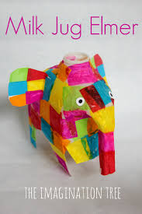
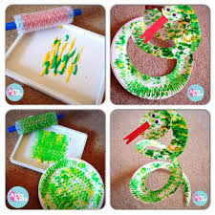
Yours sincerely,
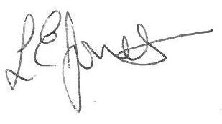

Louise Jones Sean Sly
Executive Head Acting Deputy Head







