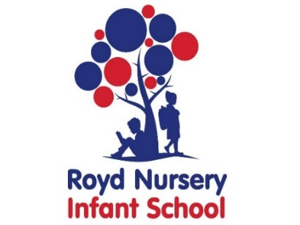
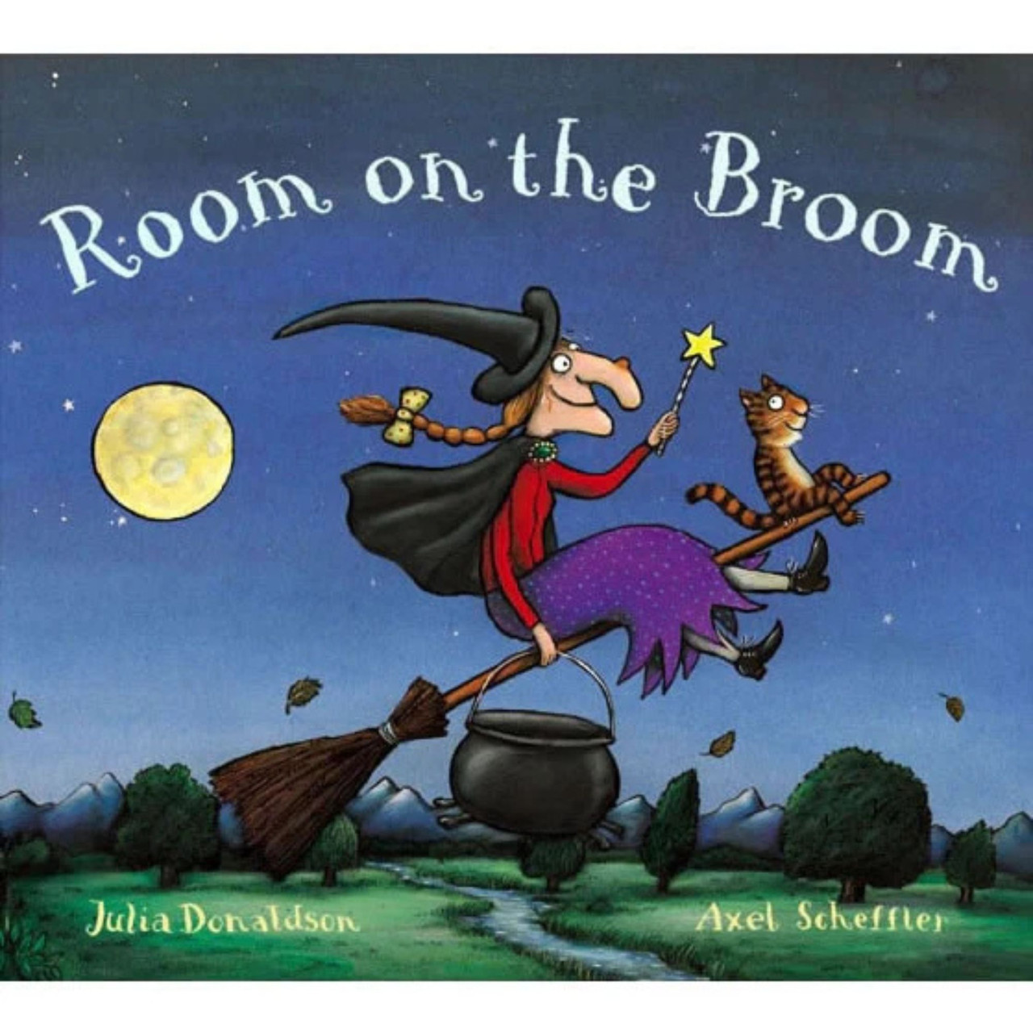
Royd Nursery Infant School
Carr Road, Deepcar
Sheffield, S36 2PR
Tel 0114 288 2594
Email enquiries@royd.sheffield.sch.uk
www.roydnurseryinfants.co.uk
Headteacher: Louise Jones

10 February 2026

WORLD BOOK DAY 2025 – Thursday 5th March 2026

Dear Parents/Carers,

On Thursday 5th March Key Stage 1 (Year 1 and Year 2) pupils will be taking part in World Book Day 2026.

This is a worldwide celebration of reading, books, authors and illustrators. A key aim of World Book Day is to give every child in the UK and Ireland a book of their own to keep, by distributing World Book Day Tokens to children. Children can exchange this token for one of eight exclusive World Book Day Books at participating booksellers.

Reading is the biggest indicator to a child succeeding in the future.

‘Reading for pleasure is the single biggest indicator of a child's future success, more than family circumstances, parents’ educational backgrounds or income.’ – Organisation for Economic Co-Operation & Development.

The children in KS1 will be reading the story “Room on the Broom”. Throughout the day children will be completing activities around this story. The children will also have a story read to them by a reading buddy from upper Key Stage 2. We are asking that children either dress up as a book character or wear some comfy pajamas for the day.

As part of our celebration of reading, we would also like to invite your child to take part in a whole school homework competition. Their task is to make something linked to their focus book “Room on the Broom”. Children will need to bring in their homework on the day when prizes will be awarded.
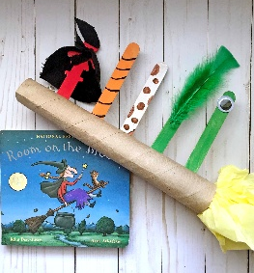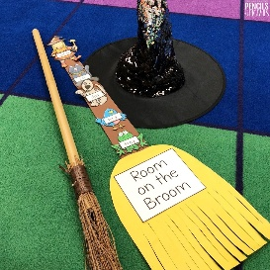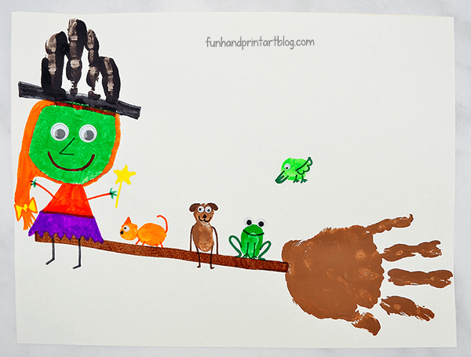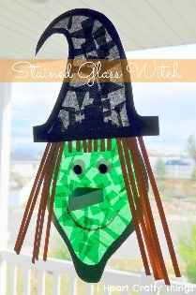

Yours sincerely,

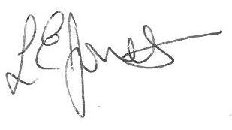

Louise Jones Sean Sly
Executive Head Acting Deputy Head










