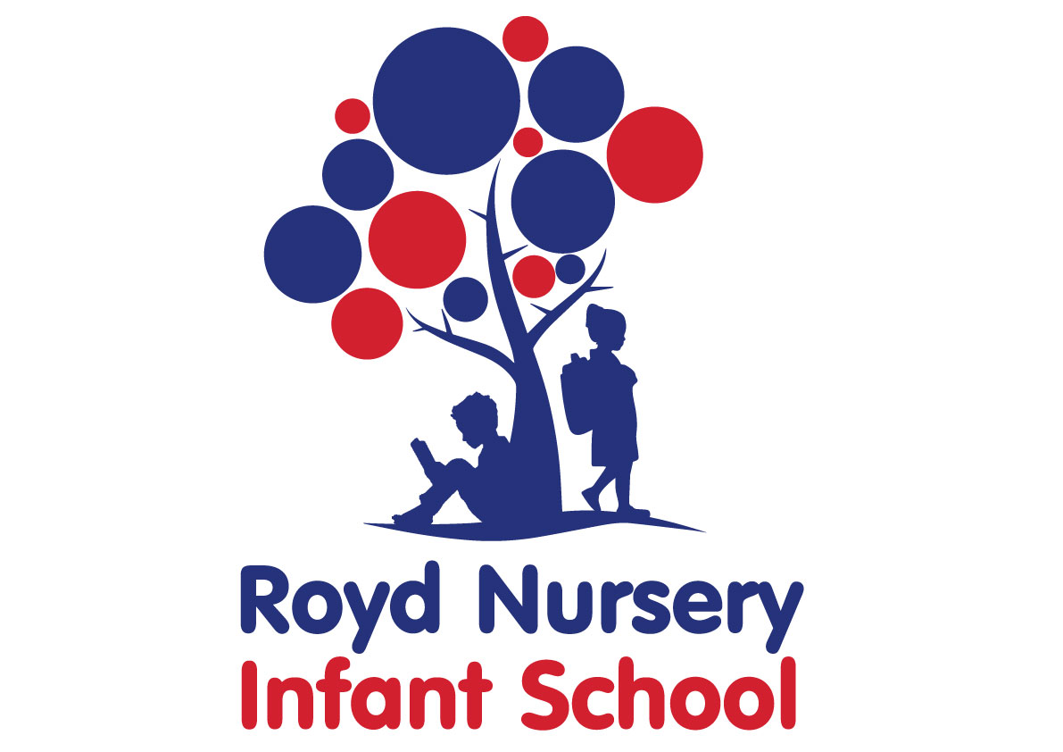
Policy: Music

Adopted by Governing Body on | September 2025
Headteacher | L Jones
Date of Review | September 2026

Contents:
Statement of intent
- Legal framework
- Roles and responsibilities
- The curriculum
- Cross-curricular links
- Teaching and learning
- Planning
- Assessment and reporting
- Resources and equipment
- Health and safety
- Homework
- Musical events and opportunities
- Equal opportunities
- Monitoring and review

Statement of intent

Royd Nursery Infant School understands that music can inspire and motivate children, and play an important role in their personal development. Music can also help children develop a greater appreciation of the world we live in, by understanding different cultures and societies through music.

Royd Nursery Infant School delivers a broad and balanced music curriculum, in line with national requirements, which enables pupils to:

- Perform, listen to, review and evaluate music across a range of historical periods, genres styles and traditions, including the works of the great composers and musicians.
- Learn to sing and use their voices.
- Create and compose music on their own and alongside their peers.
- Have the opportunities to learn a musical instrument, use technology properly and to progress to the next level of musical excellence.
- Understand and explore how music is created, produced and communicated, including through the inter-related dimensions: pitch, duration, dynamics, tempo, timbre, texture, structure and appropriate musical notations.

Legal framework
This policy has due regard to all relevant legislation and guidance including, but not limited to, the following:
- Education Act 2002
- Children Act 2004
- The Equality Act 2010
- DfE (2013) ‘Music programmes of study: key stages 1 and 2’
- DfE (2014) ‘The national curriculum in England’
- DfE (2015) ‘Special educational needs and disability code of practice: 0 to 25 years’
- DfE (2021) Model Music Curriculum: Key Stages 1 to 3
- DfE (2023) DfE (2024) ‘Statutory framework for the early years foundation stage’
- DfE (2024) ‘Working together to improve school attendance’
- DfE (2023) ‘Early years foundation stage profile handbook’
- DfE (2022) ‘The power of music to change lives: a national plan for music education’
This policy operates in conjunction with the following school policies:
- Homework Policy
- Pupil Equality, Equity, Diversity and Inclusion Policy
- Accessibility Policy
- Accessibility Plan
- Primary Assessment Policy
- Extended Services Policy
- Special Educational Needs and Disabilities (SEND) Policy

Roles and responsibilities

The governing board is responsible for:

Approving this policy.

Liaising with the headteacher, subject leader and teachers with regards to pupil progress and attainment.

Ensuring the music curriculum is inclusive and accessible to all.

The headteacher is responsible for:

Communicating the agreed music curriculum to the governing board on an annual basis.

Ensuring the music curriculum is inclusive and accessible to all.

Assisting teachers with the planning and implementation of the music curriculum, ensuring their workload is manageable.

Ensuring the music curriculum is implemented consistently throughout the school and ensuring any difficulties are addressed and mitigated as soon as possible.

Receiving reports on the progress and attainment of pupils and reporting these results to the governing board.

Making any necessary adjustments to the curriculum where required.

Keeping up to date with any relevant statutory updates and taking action where required.

Ensuring the music curriculum is created in accordance with this policy.

Ensuring there is a school music development plan published on the school website.

Updating and maintaining this policy.

The subject leader is responsible for:

Preparing policy documents, curriculum plans and schemes of work for the subject.

Reviewing changes to the national curriculum and advising teachers on their implementation.

Monitoring the learning and teaching of music, providing support for staff where necessary.

Ensuring the continuity and progression from year group to year group.

Encouraging staff to provide effective learning opportunities for pupils.

Helping to develop colleagues’ expertise in the subject.

Organising the deployment of resources and carrying out an annual audit of all music-related resources.

Liaising with teachers across all phases.

Communicating developments in the subject to all teaching staff and the SLT, as appropriate.

Leading staff meetings and providing staff members with the appropriate training.

Organising, providing and monitoring CPD opportunities in the subject.

Ensuring common standards are met for recording and assessing pupil performance.

Advising on the contribution of music to other curriculum areas, including cross-curricular and extracurricular activities.

Collating assessment data and setting new priorities for the development of music in subsequent years.

Writing and reviewing the school music development plan published on the school website.

Music teachers are responsible for:

Acting in accordance with this policy.

Ensuring progression of pupils’ musical skills, with due regard to the national curriculum.

Planning lessons effectively, ensuring a range of teaching methods are used to cover the content of the national curriculum.

Liaising with the subject leader about key topics, resources and support for individual pupils.

Monitoring the progress of pupils in their class and reporting this on an annual basis to parents.

Reporting any concerns regarding the teaching of the subject to the subject leader or a member of the SLT.

Undertaking any training that is necessary in order to effectively teach the subject.

EYFS

All pupils in the EYFS will be taught music as an integral part of the topic work covered during the academic year. All musical objectives within the EYFS are underpinned by the objectives of the early learning goals (ELGs).

The music curriculum in the EYFS is delivered with particular reference to being imaginative and expressive, which enables children to:

· Sing a range of well-known nursery rhymes and songs

· Perform songs, rhymes, poems and stories with others

· Try to move in time with music, when appropriate

The curriculum
  - The school aims to assist pupils in achieving attainment targets set out in the national curriculum. By the end of each key stage, pupils are expected to know, apply and understand the matters, skills, and processes specified in the national curriculum. Pupils will learn a broad range of subject knowledge and draw on disciplines such as maths, science, computing and art.

EYFS
  - All pupils in the EYFS are taught Music as an integral part of the topic work covered during the academic year.
  - All music objectives within the EYFS are underpinned by the following three prime areas outlined in the ‘Statutory framework for the early years foundation stage’:
- Communication and language
- Physical development
- Personal, social and emotional development
  - There are four specific areas through which the three prime areas are strengthened and applied:
- Literacy
- Mathematics
- Understanding the world
- Expressive arts and design
  - The music curriculum in the EYFS focusses on the specific areas of understanding the world and expressive arts and design, exploring and using media and materials.
  - Pupils will be taught to:
- Sing songs, make music and dance, and experiment with ways of developing the sounds and movements used.
- Represent their own ideas, thoughts and feelings through design and technology, art, music, dance, role-play and stores.
- Explore and engage in music making and dance, performing solo or in groups.
- Listen attentively, move to and talk about music, expressing their feeling and responses.

KS1
  - Pupils will be taught to:
- Use their voices expressively and creatively by singing songs and speaking chants and rhymes.
- Play tuned and untuned instruments musically.
- Listen with concentration and understanding to a range of high-quality live and recorded music.
- Experiment with, create, select and combine sounds using the inter-related dimensions of music.

Cross-curricular links
  - English
- Pupils develop their reading and writing skills through learning to read and interpret written music.
- Pupils develop their language skills through singing songs, with alteration to diction, meaning, rhythm and rhyme.
- Pupils develop their communication and listening skills through learning to listen to and interpret music, and communicate their ideas effectively.
- Pupils develop their research skills through discovering the history of music and famous composers.

  - Mathematics
- Pupils develop their understanding of patterns and processes, through practising rhythm and paying attention to the structure of music.
  - Computing
- Pupils learn to use technology to compose music, and enhance their research skills through the internet and CD ROMs.
- Pupils listen to music electronically and record compositions electronically.
- Pupils are able to present their work using programs such as Word and PowerPoint.
  - Spiritual, moral, social and cultural development
- Pupils learn to work effectively with their peers and others, and build positive relationships.
- Pupils learn to build their self-confidence through learning to play musical instruments and participating in musical performances.
- Pupils learn to reflect on mood and senses through listening to and interpreting music.
- Pupils develop an understanding of other cultures and develop positive attitudes through appreciating music from other societies.

Teaching and learning
  - Music lessons are delivered through continuous provision for pupils in the EYFS. KS1 children receive a block of music lessons during topic lessons depending on whether music is a focus for that half term. Children in KS1 also have a daily assembly that involves singing and music.
  - The school uses a variety of teaching and learning styles in music lessons that are matched to the activity and ability of pupils. The main aim of these lessons is to develop pupils’ knowledge, skills and understanding.
  - Teaching and learning styles are adapted to support pupils with SEND to ensure these pupils continue to have their confidence and self-esteem raised.
  - Teachers ensure pupils apply their knowledge and understanding when developing ideas, planning and producing music, and evaluating these.
  - Pupils will be taught to describe key characteristics and associated processes in common language, as well as understand and use technical terminology and specialist vocabulary.
  - The school uses a mixture of whole-class teaching, group work and individual activities. Pupils are given the opportunity to work on their own and collaborate with others, listening to their peers’ ideas and treating these with respect.
  - Principles for effective teaching include:
- Setting tasks in the context of pupils’ prior knowledge.
- Promoting active learning.
- Inspiring, exciting and motivating pupils to know more.
  - Strategies for effective teaching include:
- Ensuring the teaching methods used suit the purpose and needs of the pupils.
- Providing a meaningful context and clear purpose when assigning tasks.
- Using focussed practical tasks to help pupils develop and evaluate music work.
- Ensuring tasks are built on skills and understanding.
  - The classroom teacher will work with the Music subject leader and curriculum team to ensure that the needs of all pupils are met by:
- Setting tasks which can have a variety of responses.
- Providing resources of differing complexity, according to the ability of the pupils.
- Setting tasks of varying difficulty, depending on the ability group.
- Utilising TAs to ensure that pupils are effectively supported.
  - As part of music, pupils are provided with topic books, which they are required to present their work in. The topic book is used to evidence pupils’ responses.
  - Topic books are used for displaying:
- Singing in tune and alongside others
- Structure and organisation of music
- Appreciating different forms of music
- Listening to music, progressing to extended pieces of music as pupils move through year groups
- Representing feelings and emotions through music
- Recognising pulse and pitch
- Using the voices of others to combine and make different sounds
- Musical notation and how to compose music
  - Topic books are an essential record of individual pupils’ experiences and ideas throughout a year, and will be seen as evidence for assessment and reporting purposes.
  - Displays of music work on topic displays are used to celebrate achievement and support teaching and learning.
  - The school promotes displays of music work on topic displays in classrooms to influence how pupils feel about their environment, convey standards and promote high expectations.
  - Displays are used to communicate ideas, stimulate interest, celebrate pupils’ work, reflect the ethos of the school and respond to pupils’ interests.

Planning
  - All relevant staff members are briefed on the school’s planning procedures as part of staff training.
  - Throughout school, music is taught as a discrete lesson and as part of cross-curricular themes when appropriate.
  - Teachers will use the key learning content in the DfE’s ‘Music programmes of study: key stages 1 and 2’ and the national curriculum as a starting point for their planning.
  - Issues of health and safety are addressed in the planning and delivery of the music curriculum.
  - Lesson plans will demonstrate a balance of interactive and independent elements used in teaching, ensuring that all pupils engage with their learning.
  - Lesson plans will demonstrate the balance of visual, auditory and kinaesthetic elements used in teaching, ensuring that all pupils with different learning styles can access the learning experience.
  - There will be a clear focus on direct, instructional teaching and interactive oral work with the whole class and targeted groups.
  - Planning of the music curriculum is focussed on creating opportunities for pupils to:
- Singing in tune and alongside others
- Structure and organisation of music
- Appreciating different forms of music
- Listening to music, progressing to extended pieces of music as pupils move through year groups
- Representing feelings and emotions through music
- Recognising pulse and pitch
- Using the voices of others to combine and make different sounds
- Musical notation and how to compose music
- Discuss ideas and planning with their peers.
- See that their work is valued, celebrated and displayed around the school.
  - The school creates long-term, medium-term and short-term plans for the delivery of the art curriculum – these are as follows:
- Long-term: includes the topics studied in each term during the key stage
- Medium-term: includes the details of work studied each term
- Short-term: includes the details of work studied during each lesson
  - The Music subject leader and curriculum team is responsible for reviewing and updating long-term and medium-term plans, and communicating these to teachers.
  - Teachers are responsible for reviewing and updating short-term plans, building on the medium-term plans, taking into account pupils’ needs and identifying the methods in which topics could be taught.
  - Long-term planning will be used to outline the units to be taught within each year group.
  - Medium-term planning will be used to outline the vocabulary and skills that will be taught in each unit of work, as well as highlight the opportunities for assessment.
  - Medium-term plans will identify learning objectives, main learning activities and differentiation.
  - Medium-term plans will be shared with the Music subject leader and curriculum team to ensure there is progression between years.
  - Short-term planning will be used flexibly to reflect the objectives of the lesson, the success criteria and the aims of the next lesson.
  - All lessons will have clear learning objectives, which are shared and reviewed with pupils.

Assessment and reporting
  - Pupils will be assessed, and their progression recorded, in line with the school’s Assessment Policy.
  - By the end of each key stage, pupils are expected to know, apply and understand the matters, skills and processes specified in the relevant programme of study.
  - An EYFS profile will be completed for each pupil in the final term of the year in which they reach age five.
  - The progress and development of pupils within the EYFS is assessed against the early learning goals outlined in the ‘Statutory framework for the early years foundation stage’.
  - The progress and development of pupils within KS1 is assessed against the descriptors outlined in the national curriculum.
  - Throughout the year, teachers will plan on-going creative assessment opportunities in order to gauge whether pupils have achieved the key learning objectives.
  - Assessment will be undertaken in various forms, including the following:
- Talking to pupils and asking questions
- Discussing pupils’ work with them
- Marking work against the learning objectives
- Pupils’ self-evaluation of their work
- Classroom tests and formal exams
  - Teachers will record pupils’ ability and progression through two types of assessment – formative and summative.
  - Formative assessment, which is carried out informally throughout the year, will be used to identify pupils’ understanding of subjects and inform their immediate lesson planning.
  - In terms of summative assessments, the results of end-of-year assessments will be passed to relevant members of staff, such as pupils’ future teachers, in order to demonstrate where pupils are at a given point in time.
  - Summative assessments are also used at the end of a unit of work. Teachers will make a judgement about the work of each pupil in relation to the national curriculum.
  - Parents will be provided with a written report about their child’s progress during the Summer term every year. This will include information on pupils’ attitudes towards art, understanding of methods, investigatory skills and the knowledge levels they have achieved.
  - Verbal reports will be provided at parents’ evenings during the Autumn and Spring terms.
  - The progress of pupils with SEND will be monitored by the SENCO.

Resources and equipment
  - The school has a selection of centrally stored materials, tools and equipment to ensure that all pupils have access to the necessary resources.
  - The school library contains resources and topic books to support pupils’ research. The school receive books form Sheffield City Council Library on the topic focus for each half term. Books are displayed in the classroom linked to the half termly topic.
  - The music budget covers the cost of materials and replacement tools. Class teachers are required to maintain the tools and equipment in their classrooms.
  - Pupils may occasionally be asked to bring materials from home if they can; however, to provide all pupils with the same opportunities, the school will provide for pupils who are unable to do this.
  - Display walls are utilised and updated on a half termly basis, in accordance with the area of music being taught at the time.
  - At the start of each school year, the Music subject leader and curriculum team will work with the head teacher to assess the school’s music tools, materials and equipment to ensure there is sufficient equipment for pupils, allowing for funds to be allocated where necessary.

Health and safety
  - Staff members will act in accordance with the school’s Health and Safety Policy at all times.
  - Accidents and near-misses will be reported following the procedure outlined in the school’s Accident Reporting Procedure Policy.
  - All staff members will be shown how to correctly use equipment as part of their induction training.
  - Any ‘new’ activities which a teacher has not used in the classroom before will be trialled prior to being performed with pupils.
  - Pupils are allowed full access to a wide range of materials in music, to maximise their learning experience; however, health and safety concerns are inherent with this subject, including storing materials and tools, and the use of equipment.
  - PPE, such as gloves and eye protection, is made available to all pupils and teachers where required.
  - The risks of each task and the tools required will be assessed by the classroom teacher and Music subject leader and curriculum team before lessons, and relevant PPE will be compulsory based on their decisions.
  - All tools and equipment will be checked before the start of every lesson by the classroom teacher.
  - Pupils will be taught to use tools and equipment properly by the classroom teacher before use. They will also be fully briefed on the importance of how to correctly use tools and equipment.
  - All tools and equipment are stored in the resource room at the end of each day. Classrooms are not accessed during lunch and break times by children to prevent unsupervised access to potentially harmful tools or equipment.

Homework
  - Homework will be set on a weekly basis and will follow and build upon curriculum content. The content of the homework will be decided by the class teacher and monitored by SLT. Throughout the academic year there will be a range of homework provided linked to differing subjects.
  - Parents will receive a weekly newsletter informing them about the main topics and units of work that will be covered.
  - Parents will be encouraged to discuss the homework that is set with their child. If they have any queries or other comments about the homework, parents should make an appointment to see their child’s class teacher.

Musical events and opportunities
  - All pupils are encouraged to participate in additional musical opportunities to enhance their learning and development.
  - The school choir meets on a weekly basis (Autumn and Summer term) to allow pupils to enjoy singing together. The school choir also performs in public on a number of occasions throughout the year.
  - The following opportunities are available:
- School choir
- After School Club Year 2 recorders

Equal opportunities
  - We are an inclusive school that ensures all pupils are provided with equal learning opportunities, regardless of social class, gender, culture, race, disability or learning difficulties. Our Equal Opportunities Policy ensures all pupils are able to achieve their potential in all areas of the curriculum.
  - In order to ensure pupils with SEND achieve to the best of their ability, outcomes are adapted, and the delivery of the music curriculum is differentiated for these pupils, in line with the school’s SEND Policy.
  - The planning and organising of teaching strategies for music will be reviewed on an annual basis by the Music subject leader and curriculum team to ensure that no pupil is at a disadvantage.
  - The school aims to maximise the use and benefits of music as one of many resources to enable all pupils to achieve their full potential.

Monitoring and review
  - This policy will be reviewed on an annual basis by the Music subject leader and curriculum team and head teacher.
  - Any changes made to this policy will be communicated to all members of staff and the governing board.
  - All members of staff directly involved with teaching music are required to familiarise themselves with this policy.

