
Royd Nursery Infant School
Carr Road, Deepcar
Sheffield, S36 2PR
Tel 0114 288 2594
Email royd.enquiries@deepcarprimarypartnership.co.uk
www.roydnurseryinfants.co.uk
Executive Headteacher: Louise Jones

9 February 2026

Dear Parent/Carers,

Parents Evening for Nursery provision, will take place on the following dates:

Miss Terry Wednesday 18 March 2026 8.30 am to 11.20 am
Miss Terry Wednesday 18 March 2026 3.30 pm to 5.50 pm
Mrs Musgrave Monday 23 March 2026 3.30 pm to 5.50 pm

Please note that the morning meetings on 18th March will take place in the main school building. Please arrive at the school office two minutes before the appointment time. The teacher will come out to collect you.

The afternoon appointments on the 18th and 23rd March will take place in the nursery buildings. Please arrive outside nursery two minutes before the appointment time. The teacher will then come out to collect you.

To ensure that everybody has a fair chance of booking an appointment, please complete the form overleaf indicating your preference and return the form by Thursday 26 March 2026 at the latest and School will endeavour to meet your request. Please note, due to the volume of replies email requests will not be accepted.

Confirmation of appointment times will be sent by letter the afternoon of Monday 2 March 2026. Thank you

Yours sincerely,
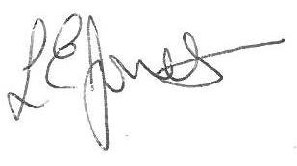

Louise Jones Sean Sly
Executive Head Acting Deputy Head











-----------------------------------------------------------------------------------------------------------------------------------------------
Nursery Provision Parents Evening March 2026

Name of Child : Class : FS1

Wednesday 18 March between 8.30 am and 11.20 am

Wednesday 18 March between 3.30 pm and 4.50 pm

Wednesday 18 March between 5.00 pm and 5.50 pm

Monday 23 March between 3.30 pm and 4.50 pm

Monday 23 March between 5.00 pm – 5.50 pm

