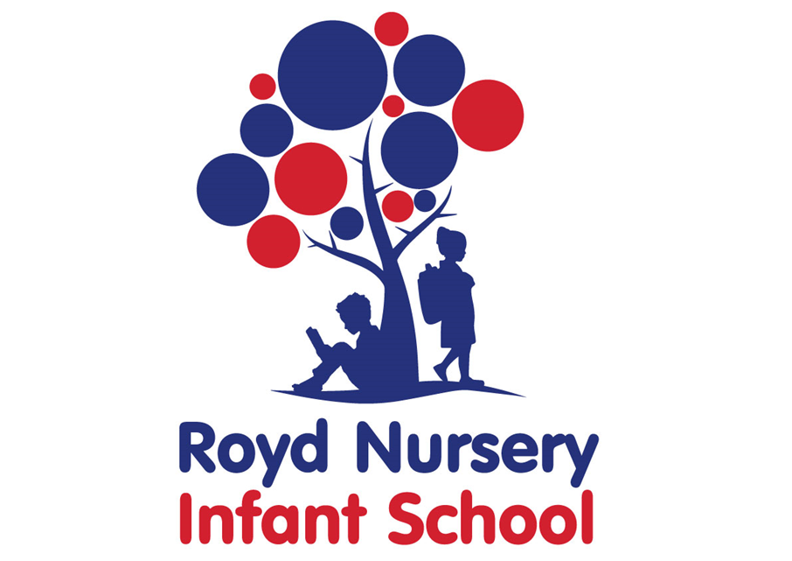

Policy: Religious Education
Adopted by Governing Body on | September 2025
Headteacher | L Jones
Date of Review | September 2026

Contents:

Statement of intent
- Legal framework
- Roles and responsibilities
- Early Years Foundation Stage (EYFS)
- Curriculum
- Teaching and learning
- Planning
- Homework
- Assessment and reporting
- Resources
- Equal opportunities
- Monitoring and review

Statement of intent
Royd Nursery Infant School recognises the effect that an inclusive teaching style can have on a pupils’ progress, both inside and outside of the school environment. At our school, we provide a broad and balanced curriculum which encompasses spiritual, moral, social and cultural development, in accordance with the locally-agreed syllabus of the LEA.
The school has created this policy in order to ensure that:
- All pupils are provided with a balanced and broad curriculum which encompasses the traditions of Great Britain as well as a variety of other mainstream religions and beliefs.
- All staff members are aware of planning, assessment, teaching and learning requirements for the RE curriculum.
- All pupils know how to plan, practise and evaluate their work.
- All pupils understand all elements of RE, as per the locally-agreed curriculum.
- All pupils receive a high level of teaching which is maintained at all times.
- Community cohesion and high standards of achievement are promoted.
- Progression of academic achievement occurs consistently throughout the key stages and post-16 study.

Legal framework
  - This policy has due regard to legislation, including, but not limited to the following:
- The Education Act 1996, section 375
- The Education Act 2002, section 78
- The School Standards and Framework Act 1998

This policy has been created with regard to the following statutory and non-statutory guidance:
- DfE (2023) ‘Religious education in English schools: Non‑statutory guidance 2010’
- DfE (2024) ‘Statutory framework for the early years foundation stage’

This policy has been created in conjunction with the following school policies:
- British Values Policy
- Equality, Equity, Diversity and Inclusion Policy

Roles and responsibilities
  - The subject leader is responsible for:
- Preparing policy documents, curriculum plans and schemes of work for the subject.
- Reviewing changes to the locally-agreed curriculum and advising teachers on their implementation.
- Monitoring the learning and teaching of RE, providing support for staff where necessary.
- Ensuring continuity and progression from year group to year group.
- Encouraging staff to provide effective learning opportunities for pupils.
- Helping to develop subject colleagues’ expertise in RE.
- Organising the deployment of resources and carrying out an annual audit of all related resources.
- Liaising with teachers across all phases.
- Communicating developments in the subject to all teaching staff and the senior leadership team (SLT) as appropriate.
- Leading staff meetings and providing staff members with the appropriate training.
- Organising, providing and monitoring CPD opportunities regarding RE.
- Ensuring common standards are met for recording and assessing pupil performance.
- Advising on the contribution of RE to other curriculum areas, including cross-curricular and extra-curricular activities, e.g. PSHE lessons.
- Collating assessment data and setting new priorities for the development of RE in subsequent years.
  - The classroom teacher(s) is/are responsible for:
- Acting in accordance with this policy.
- Ensuring progression of pupils’ RE, with due regard to the locally-agreed syllabus of the LEA.
- Planning lessons effectively, ensuring a range of teaching methods are used to cover the content of the locally-agreed syllabus of the LEA.
- Liaising with the subject leader about key topics, resources and support for individual pupils.
- Monitoring the progress of pupils in their class and reporting this on an annual basis to parents.
- Reporting any concerns regarding the teaching of the subject to the subject leader or a member of the SLT.
- Undertaking any training that is necessary in order to effectively teach RE.
  - The special educational needs coordinator (SENCO) is responsible for:
- Liaising with the subject leader in order to implement and develop specialist writing-based learning throughout the school.
- Organising and providing training for staff regarding the RE curriculum for pupils with special educational needs and disabilities (SEND).
- Advising staff on how best to support pupils’ needs.
- Advising staff on the inclusion of learning objectives in pupils’ individual education plans.
- Advising staff on the use of teaching assistants in order to meet pupils’ needs.

Early Years Foundation Stage (EYFS)
All children in the EYFS will be taught RE as an integral part of their learning, in line with the following Early Learning Goals:
- Personal, social and emotional development
- Understanding the world
All children will encounter religions and world-views through multiple methods of teaching, e.g. books, educational visits and storytelling.
All children will reflect on their feelings and experiences.
Teachers will encourage imaginative play and curiosity in children.
All RE teaching and learning will have regard to the most up-to-date version of the DfE’s EYFS framework.

Curriculum
  - Royd Nursery Infant School adheres to the locally-agreed syllabus of the LEA.
  - RE provision will include a distinct body of knowledge and will enable all pupils to make effective progress in achieving RE learning outcomes.
  - The school will make provisions to account for parents’ right to withdraw their child from RE lessons.
  - All pupils will have a high quality, coherent and progressive experience of RE.
  - The school will decide the attitudes and skills they wish to emphasise across a school year or key stage, which meets the needs of the pupils.
  - The school will ensure that RE provisions contribute to the cross-curricular dimensions of the wider curriculum.
  - [Maintained primary schools only] Pupils will be introduced to issues of right and wrong, good and evil, conflict and justice.
  - [Maintained secondary schools only] Pupils will be introduced to issues of crime and punishment, sex and relationships, addiction and dependency, diet and body image.
  - Good practice for the curriculum include:
- Exploring controversial issues in the modern world.
- Working with local communities who promote the beliefs taught in lessons.
- Learning outside the classroom by participating in educational visits
- Introducing themed days and assemblies which celebrate different beliefs.
- Encouraging pupils to deploy their skills and reflect on questions regarding truth and morality.
- Promoting debate and dialogue of pupils within their local community.

Teaching and learning
  - [Primary schools only] The RE curriculum is delivered at least once a week for KS1.
  - Classroom teachers use high-quality texts and resources which model the religious and non-religious beliefs of Great Britain, in accordance with the school’s British Values Policy.
  - Classroom teachers encourage pupils to discuss topics covered in RE, orally with their peers and as a whole class.
  - During RE lessons, sufficient time is given for pupils to discuss, plan, edit and revise their work.
  - To improve understanding of the topic, several methods of teaching is deployed including but not limited to:
- Storytelling.
- Adult-led activities.
- Child initiated activities.
- Debating.
- Dramatic performance.
  - To improve communication and language in the classroom, teachers will encourage pupils’:
- Organisation, clarification and sequencing of thoughts, feelings and ideas.
- Development of their own narratives in relation to the stories they hear in lessons.
- Exploration of their feelings and emotions towards set narratives.

Planning
  - All lessons will have clear learning objectives, which are shared and reviewed with pupils.
  - Planning for RE will be comprised of long-term, medium-term and short-term planning which will be carried out by the relevant member of staff, e.g. the classroom teacher.
  - Long-term plans will be created by the subject leader and will include the topics studied in each term during the key stage.
  - Medium-term plans will be established by the subject leader and the details of work studied each term will be outlined for the teacher to build upon.
  - Short-term plans will include the details of work studied during each lesson. The subject aims and lesson objectives will be outlined by the teacher and referred to the subject leader for verification.
  - The subject leader is responsible for reviewing and updating long-term and medium-term plans on an annual basis, and communicating these to teachers prior to the start of a new term.
  - Teachers are responsible for reviewing and updating short-term plans, building on the medium-term plans, taking into account pupils’ needs and identifying the methods in which topics could be taught.
  - Short-term plans will reflect the lesson objectives and proceeding aims of future lessons.
  - Medium-term plans will identify the main learning objectives of RE, learning activities and differentiation. This information will be shared with the subject leader to ensure there is a visible progression between years.

Homework

Homework will be given on a weekly basis.
  - [Primary schools only] Pupils’ will be presented with homework which will be designed to last between 10-15 minutes for reception - Year 2 pupils. The duration of tasks will increase with an increment of five minutes per year group.

Homework will be made relevant to the weekly learning objectives.

It is at the discretion of the teacher to set extra homework if it is required.

Tasks will exercise pupils’ core skills of reading, writing and spelling.

Spelling with be assessed in accordance with the school’s spelling policy.

Assessment and reporting
  - Pupils will be assessed using methods of formative and summative assessment throughout the year.
  - Formative assessment will be carried out routinely throughout the year; assessment will be carried out at the conclusion of each topic to measure pupils’ development throughout each half-term.
  - The results from formative assessments will be used to inform teachers’ lesson plans.
  - Summative assessment will be carried out at the end of a unit of work. Teachers will use the results to assess pupils’ overall achievement for each half term. This information will be passed on at the end of the school year to each pupil’s future teachers, in order to measure how well a pupil has progressed at any given time in their education.
  - All grades will be reported to the pupils in spoken and written form at the conclusion of each assessment by the subject teacher.
  - Standardised tests will be used once a year, towards the end of the academic year, to measure each pupil’s attainment in all areas of RE. These results will be compared with an ‘average’ for all pupils of that age.
  - Verbal reports will be provided at parent-teacher interviews during the Autumn and Spring terms.
  - Parents will be provided with a written report about their child’s progress during the Summer term every year. These will include information on pupils’ attitudes towards RE and understanding of the key concepts.
  - The progress of pupils with SEND will be monitored by the SENCO.

Resources
  - The subject leader is responsible for the management and maintenance of writing resources, as well as for liaising with the school business manager to purchase further resources.
  - Writing resources, such as books, dictionaries and thesauruses, are stored in each classroom.
  - Display walls will be utilised and updated on a termly basis, in accordance with the topics being taught at the time.
  - Writing equipment and resources will be easily accessible to pupils during lessons.
  - The school library contains an array of resources to support pupils’ learning.
  - The subject leader will undertake an audit of writing equipment and resources on an annual basis.

Equal opportunities
  - All pupils will have equal access to the RE curriculum.
  - Learning ability, physical ability, linguistic ability, gender, ethnicity and/or cultural circumstances will not impede pupils from accessing RE lessons.
  - When a pupil’s participation in RE lessons is restricted due to the factors outlined above, the lessons will be adapted to meet the pupil’s needs.
  - Cultural and gender differences are positively reflected in RE lessons and the teaching materials used.

Monitoring and review

This policy will be monitored and reviewed on an annual basis by the subject leader.

The scheduled review date for this policy is October 2018.
  - The subject leader will review the teaching of RE in the school, ensuring that taught content adheres to the locally-agreed syllabus of the [LA/academy trust].
  - [Maintained schools only] The subject leader and a nominated member of the governing board will attend the Agreed Syllabus Conference (ASC) to review the locally-agreed syllabus of the LA.
  - Any changes to the locally-agreed syllabus of the LEA will be communicated to the headteacher.
  - Any changes to this policy will be communicated to all teaching staff.

