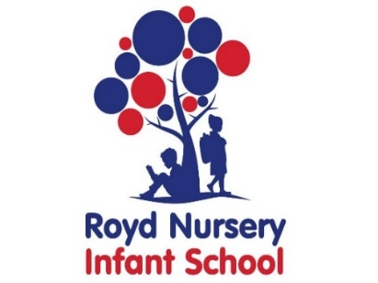
Royd Nursery Infant School
Carr Road, Deepcar
Sheffield, S36 2PR
Tel 0114 288 2594
Email enquiries@royd.sheffield.sch.uk
www.roydnurseryinfants.co.uk
Headteacher: Louise Jones

May 2026

Dear Parents /Carers,

The School Council are holding a competition.

We would like children to create an Eco Code for our School. The winner will receive a prize, and their code will be the new school Eco code on display. We have put a few examples below to help.

Please give your brilliant designs to your class teacher on or before Wednesday 13th May.

Many Thanks,
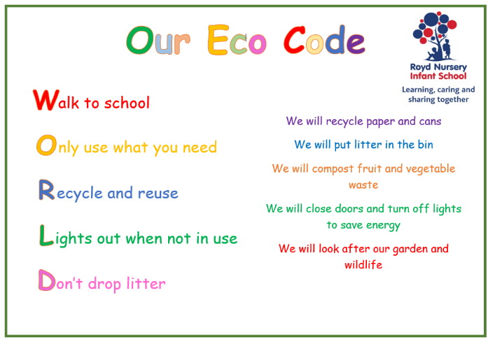



The School Council
