
Royd Nursery Infant School
Carr Road, Deepcar
Sheffield, S36 2PR
Tel 0114 288 2594
Email royd.enquiries@deepcarprimarypartnership.co.uk
www.roydnurseryinfants.co.uk
Executive Headteacher: Louise Jones

30 September 2026

Dear Parents / Carers

We would like to invite you in to School for a Stay and Play session with your child on
Wednesday 21st October 2026 @ 2:15-3:00 PM

There will be a carousel of activities where children will be able to explore and investigate enhanced provision activities, based around their current topic ‘Why do you love me so much’? The session will be from 2.15pm – 3:00pm.

Should your child not attend provision on a Wednesday, parents/carers are welcome to join the session. Your child must be accompanied by an adult due to ratio’s.

Please complete and return the slip below or email enquiries@deepcarprimarypartnership.co.uk if you would like to join us. It would be lovely to see you all.

Yours sincerely,

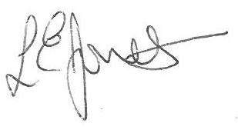
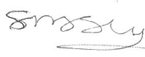

Louise Jones Sean Sly
Executive Head Acting Deputy Head

________________________________________________________________________________

2-Year-Old Stay and Play Autumn 1 2026

Name of child Class:

Yes I / We would like to join you for the Stay and Play

No I / We are unable to attend.

Signed ____________________________________________________ Parent/carer











