This Week
This week in Nursery we have been exploring our new provision areas, in line with our theme “Why do you love me so much?”. The children have been busy painting pictures of hares from our focus book ‘The Tiger Who Came to Tea” and they have been creating some super paper plate tiger faces using a range of different materials. In our painting area have been encouraging children to add facial features to face outlines and identify the different body parts. In our maths area, children have been exploring with our ‘Royd car park’, they have had to match the correct numbers on the cars to the correct colour parking spaces.
We have begun with our shared read book, ‘The Tiger Who Came to Tea”. We have listened to the story we did some investigation work on what a ‘grocer’ is using the interactive white board and we answered verbal questioned based on a section of the book.
We have continued to introduce phonics we have recapped m and a, this week. Please use the following video when helping your child consolidate their phonics learning as we need consistency for them at home and school.
m phonics sound- https://www.youtube.com/watch?v=bERDmffRz3E&list=PLetiKvWftA5uqqoq6YdNAMYNA-I-WQ3yJ&index=2
a phonics sound- https://www.youtube.com/watch?v=EJ_W2ixU7TA
Please see Mrs Musgrave or Miss Terry if you have any questions regarding phonics and how to support at home.
Attendance- 98.9%
Next week:  We shall be learning: s and d in phonics.  Nursery are on the hunt for some conkers!  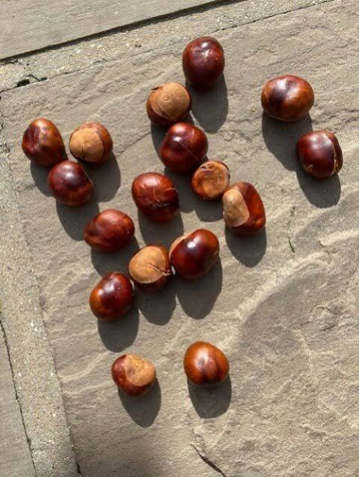  Can you collect any for us? Let’s see who can find the most! Please hand these to a member of staff in nursery next week.  Thank you! | Stars of the week  Mari, Margot & Theo.  
Homework
Homework will be given out to children on their last day of every week. Please ensure this is physically handed in either by your child or yourself as members of staff do not check children’s bags.
If you have lost your home work or did not receive one due to absence, please collect your own copy from the notice board in the entrance to Nursery.
Reading books
Children in Nursery are encouraged to select a book from the book box on the carpet area. Children should keep the same book for a week and return these on their last day of Nursery every week. Please ensure you change your child’s book with them in the morning.
Online Safety
The Education for a Connected World framework is used by Royd Nursery Infant School to support in the delivery of online safety. It is a tool for anyone who works with children and young people. It enables the development of teaching and learning as well as guidance to support children and young people to live knowledgeably, responsibly and safely in a digital world.
It focuses specifically on eight different aspects of online education. Strand 2 focuses on “Online relationships”
To view Strand 2 “Online relationships” please click on the following link and scroll to page 10 and 11 (if you would like to know more about this strand and what is covered from ages 7 – 18 please scroll to pages 12 – 14):

https://assets.publishing.service.gov.uk/media/5efa05b4e90e075c5492d58c/UKCIS_Education_for_a_Connected_World_.pdf

Reminders
Please remember to let staff aware if your child is being collected by a different adult. Please can we ask you tell us the name of the adult collecting the child and add it to the child collection board as you enter nursery.

Polite reminder that juice is NOT allowed in Nursery or school. Children are to bring in a bottle of water every day to ensure they are kept hydrated. This also applies for lunch boxes too.
A gentle reminder that we are a nut free school, this also means that if packs state ‘may contain traces of nuts’ this also cannot be provided in children’s pack lunches. Also, within our healthy school policy we ask that sweets and chocolate are not provided in pack lunches. Thank you for understanding.
Please ensure you chose your child’s dinner on the interactive whiteboard with them in the morning before leaving them or you notify them if they are a school dinner or packed lunch.
We open nursery from 8.40am-8.50am, we ask that you read the book or practise their name writing using the name card sheets from their draw and a whiteboard pen from the writing area from and return it after the shaker has been shaken at 8.50am. Books will be changed weekly by a staff member.
Thank you.


