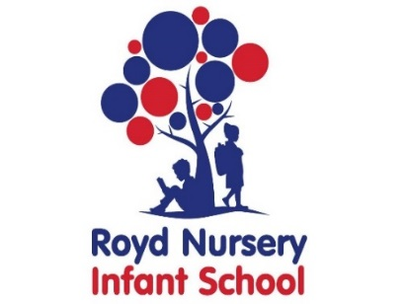
Royd Nursery Infant School
Carr Road, Deepcar
Sheffield, S36 2PR
Tel 0114 288 2594
Emailenquiries@deepcarprimarypartnership.co.uk
www.roydnurseryinfants.co.uk
Headteacher: Louise Jones

28th September 2026

Dear Parents / Carers

We would like to invite you in to School for a Stay and Play session with your child on
- Tuesday pm 13th October 2026 OR
- Thursday pm 15th October 2026

There will be a range of activities where children will be able to explore our termly topic ‘Why do you love me so much? The sessions will be from 1.40pm – 2.40pm on Tuesday 13th October or 1.40pm – 2.40pm Thursday15th October.

Should your child not attend provision on Tuesday or Thursday, parents/carers are welcome to join either session and school must be notified of the date you wish to attend. Your child must be accompanied by an adult due to ratio’s.

Please complete and return the slip below or email enquiries@deepcarprimarypartnership.co.uk if you would like to join us. It would be lovely to see you all.

Yours sincerely,
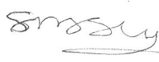
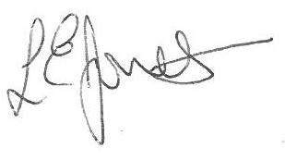

Louise Jones Sean Sly
Executive Head Acting Deputy Head

Nursery Provision Stay and Play October 2026

Name of child : Class: Nursery

Yes I / We would like to join you for the Stay and Play

Please select either 13th October pm OR 15th October pm

No I / We are unable to attend.

Signed ____________________________________________________ Parent/carer











