2 Year Provision Newsletter – w/c 28/09/26
Last week
In 2 year provision last week we began doing activities around our theme ‘Why do you love me so much!
The children have been looking closely at what makes each of us unique and talking about the people who are special and important to us. We enjoyed sharing baby and family photographs, and the children loved looking at these during group times, recognising familiar faces and talking about their families.
Through these conversations and activities, the children have been developing their understanding of themselves, their families and relationships.
A huge thank you to all our families for sharing your lovely photographs with us.
We have also created a very special classroom display celebrating ‘why we love each and every one of our children so much!’ We hope you enjoy looking at it as much as we enjoyed making it.
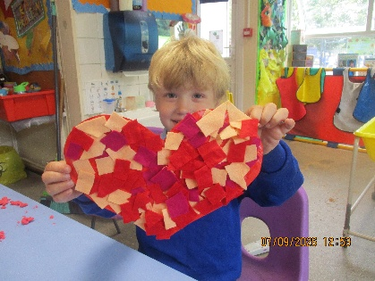
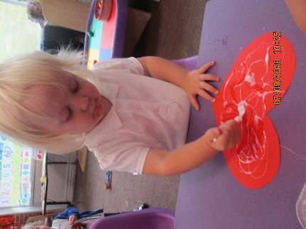
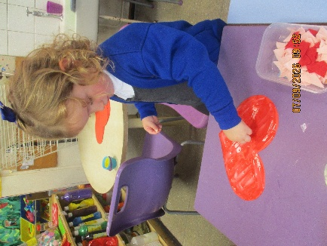

This week  This week we are continuing our theme ‘Why do you love me so much’. So, we are still learning ‘all about me’ and looking at the people in our lives, who live with us and about friendships.  This links in nicely to our book of the week ‘The Smeds and The Smoos. We will be doing various activities linked to this book.  We are also singing the nursery rhyme 5 little men in a flying saucer you may want to do this at home too. | Book of the week  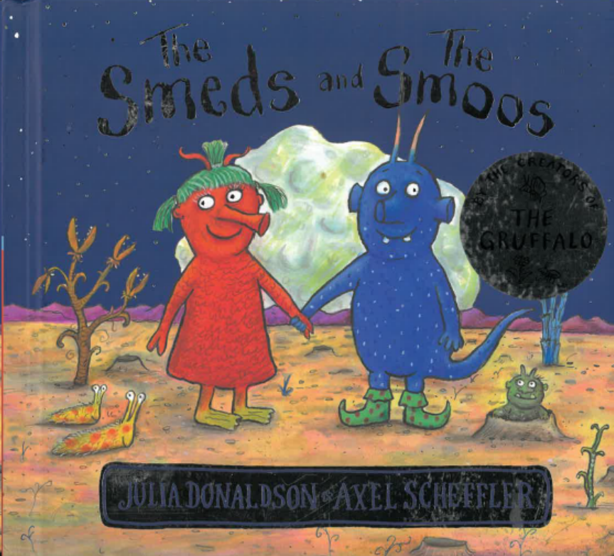  This story is linked to our theme we are running this week. Maybe if you have this story at home you could look though the story together at bedtime.
Dates for your diary
Individual class photos – Tuesday 13th October

*if your child attends the 2-year provision or Nursery and DOES NOT attend on a
Tuesday but you would like a photograph taken, this session will be between 9am and
9.30am. Please arrive at school for 9am.

Reminder
Please remember to ensure all your child’s clothing and water bottles are labelled and if you could provide spare clothes in their bag as we are very low on spare clothes.

Now the weather is turning a bit cooler can you please ensure your child brings a warm coat. We will be playing out in all weathers so if you would like to provide them with some wellingtons in a labelled carrier bags as we have some large puddles which develop when it rains heavy and children love to jump in muddy puddles!

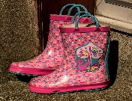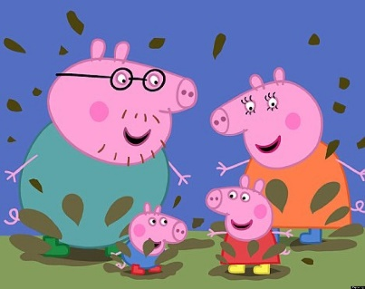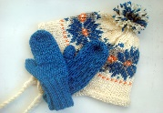
This Photo by Unknown Author is licensed under CC BY-NC-ND
This Photo by Unknown Author is licensed under CC BY-NC-ND



