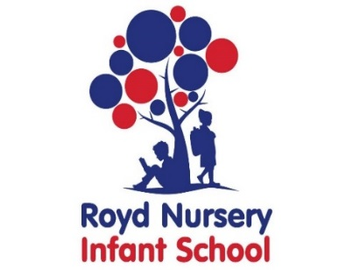
Royd Nursery Infant School
Carr Road, Deepcar
Sheffield, S36 2PR
Tel 0114 288 2594
Email enquiries@royd.sheffield.sch.uk
www.roydnurseryinfants.co.uk
Headteacher: Louise Jones

Dear Parents/Carers,

You applied to us for a place for your child at the two year old provision in Royd Nursery Infant School.

Currently, parents/carers for all 2 to 3 year-olds in England need to apply for funding via the Local Authority. To apply please go to https://www.sheffield.gov.uk/home/schools-childcare/childcare-free-early-learning/free-education-and-childcare-for-2-year-olds
Should you not qualify for funding, the three hour sessions are charged at £18.00 each*.

If you would like your child to attend the Royd Nursery two year provision please complete the form below indicating the sessions required and return within the next week. Alternatively, email Mrs Stuart at pstuart@royd.sheffield.sch.uk

We will try to accommodate all session requests however, please note that this cannot be guaranteed.

We look forward to hearing from you.

Yours sincerely,
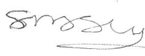
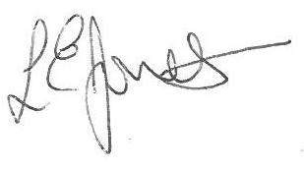

Louise Jones Sean Sly
Executive Head Acting Deputy Head

*price correct at time of printing

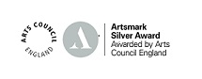







Two Old Starters

Name of Child :

Date of Birth:

Address:

Postcode:

Telephone :

Email:

Morning session 9.00 am 12.00 pm this includes lunch time
Afternoon session 12.00 pm 3.00 pm lunch at home
All day session 9.00 am 3.00 pm this includes a lunch time

One session consists of 3 hours and is currently charged at £18.00*.

Mon AM | Mon PM | Tue AM | Tue PM | Wed AM | Wed PM | Thur AM | Thur PM | Fri AM | Fri PM

If you are eligible for your child to attend for 15 hours please complete the details below. Thank you.

Name of Parent _____________________________________________

Date of Birth

National Insurance Number

Funding Authorisation Code (if applicable)

* price correct at the time of printing

