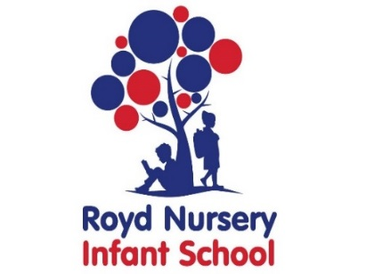
Royd Nursery Infant School
Carr Road, Deepcar
Sheffield, S36 2PR
Tel 0114 288 2594
Email royd.enquiries@deepcarprimarypartnership.co.uk
www.roydnurseryinfants.co.uk
Executive Headteacher: Louise Jones

28 September 2026

Dear Parents/Carers

The topic next half term is Towers, Tunnels and Turrets. To promote the topic and the features of castles we will be taking the Year 1 and Year 2 children to Warwick Castle. Both year groups will be going on Wednesday 4th November 2026.

This will involve an earlier start to the school day as we shall be departing school at 8.00 am prompt. The children must be at school by 7.45 am for registration. If you would like to volunteer as helper, please inform your child’s class teacher.

It will be a full day visit, and children need to wear their school uniform with suitable clothing and footwear for walking around. School will provide a packed lunch (sandwich will be ham or cheese). If you wish to send your child with your own packed lunch, please indicate this on Parentpay. Children will need to bring their water bottle.

The cost of the trip will be £24 per child. This will cover the cost of £1450.00 for the coaches and £720 entry for the children.

The coach will be leaving Warwick Castle at 2.00 pm and we expect to arrive back at School at around 5.00 pm. Should the coach be late back, please wait in the School Hall.

If you would like your child to attend, contributions, sandwich choice and consent are by Parentpay. Please complete this by the morning of Wednesday 21 October 2026. If there are any issues, please do not hesitate to contact Mr Sly. Thank you.

Yours sincerely,

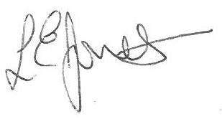
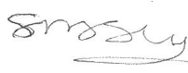

Louise Jones Sean Sly
Executive Head Acting Deputy Head



