
October 2026
Wear it Pink
Dear Parents/Carers,
On Thursday 22nd October, Deepcar St John's and Royd Nursery Infant School will be taking part in Wear It Pink Day. Breast Cancer Now is the UK's largest breast cancer charity, funding vital research into this devastating disease.
Every year, nearly 60,000 people hear the words, "It's breast cancer." Sadly, over 11,000 people lose their lives to the disease each year.
We would like to support this important cause by asking for a donation of at least £1 for children to come dressed in something pink. This could be pink socks, a T-shirt, dress, hat, hair accessory, feather boa, or any other pink item of clothing. If your child does not have anything pink, they are welcome to wear an item of red clothing instead.
Many staff members, both past and present, across our schools have been affected by breast cancer, making this a cause that is very close to our hearts. We are sure that many of you will also know someone whose life has been touched by this disease and will wish to support us.
If your child does not wish to take part, they should attend school in their normal uniform.
Please make your donation using the following link:
https://www.justgiving.com/page/deepcar-st-johns-ce-junior-school-and-royd-ni-school-5?utm_medium=FA&utm_source=CL
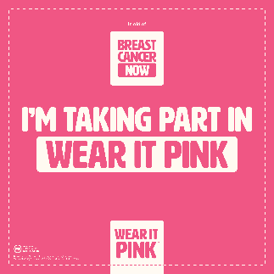
Thank you, as always, for your continued support.
Yours sincerely,
Louise Jones
Executive Head Teacher
Deepcar Primary Partnership

